**PAMF PROMS Orthopedics**

**EDC Conversion / Nov 1, 2017**

**General**

**:**

* The goal in any Electronic Data Collection (EDC) project is to use a coding and template approach that accommodates reusability from one project to the next, to yield time and cost efficiency. To that end, build on the current MS-Share questionnaire approach for this project, with an eye on reusability going forward too.
* The PAMP PROMS questionnaires are attached in Word to give you the scope for costing. We will provide you with the QPro images and URLs in a Tech Spec document – and you are asked to use the Qpro version as your style guideline.

**Supported Devices and Browsers:**

* Functions well on major browsers including Chrome, Microsoft common browsers (IE10, IE11, Edge), Safari, Firefox .
* Functions well on all devices: desktop, laptop, tablets, iPhones, Android phones.

**Overall Visual Design:**

* Overall the page layout and format need to visually match the QPro URLs. This includes (but it not limited to) using the proper font style and size, format for response scales (e.g., horizonal or vertical display), scale spacing, exact same button/check-box appearances, etc.
  + Needs to be a responsive design for tablets and phones.

**Questionnaire Design and Skip Logic:**

* There are four short questionnaires.

#1 and #2: The HOOS or KOOS questionnaire (a patient gets one or the other)

* + - **HOOS** is given to patients with a Hip surgery. It has 6 questions.
    - **KOOS** is given to patients with a Knee surgery. It has 7 questions.

#3: The **PROMIS** Global questionnaire. It has 10 questions.

#4: The **Collaborate** questionnaire. It has 3 questions.

* Patients complete a “questionnaire bundle” that includes …
  + the HOOS or KOOS questionnaire, followed by
  + the PROMS questionnaire.

The questionnaire bundle is sent at designated times (cycles) including at Pre-Op, Post-Op 3 months, Post-Op 6 months, Post-Op 9 months, Post-Op 12 months. This should not impact scope/costing, just FYI.

The questionnaire never changes across the cycle periods. However, we do tailor the intro paragraph found above Q1 in the HOOS/KOOS questionnaire to indicate the cycle period (e.g., Post-Op 3 months) and the procedure (hip or knee). We will specify how the tailoring is done in the Tech Specs.

* Patients complete the Collaborate questionnaire once, during the Pre-Op cycle. (Noted as FYI; like the HOOS-KOOS/PROMIS bundle, the number of periods sent to a patient should not impact coding costs.)
* The HOOS/KOOS and PROMIS questionnaire “bundle” and Collaborate follow this flow:
  1. An email or mail invite is sent to the patient. The PROMS app determines if it’s an email or mail send out.
     + Sutter is responsible for creating and sending both the email and mail invites
  2. Patients go to the landing page.
     + Netwoven is responsible for creating the landing page. See the example in the Appendix.
  3. Patients complete the questionnaire. If the bundle, they complete both HOOS or KOOS and PROMIS. If Collaborate, it’s the one questionnaire and done.
  4. We will share detail about where the patient is sent after questionnaire completion in the Tech Specs.
* Question page-breaks will be shown in each QPro questionnaire. We will make one slight change to the way the questions are grouped in one of the HOOS or KOOS questionnaires (TB
* There is no conditional skip logic; everyone views all questions.
* All ‘required’ questions (noted with an asterisk) must be answered; if not, display an error message indicating a question must be answered.

**Schedule:**

Needed ASAP. Ideal is to complete PAMF PROMS EDC Conversion development and testing and move to production by the end of November.

**Contact:**

Michael Lehman

[lehmanm@sutterhealth.org](mailto:lehmanm@sutterhealth.org)

503 756-3377

**APPENDIX**

**PROMS Landing Page for HOOS/KOOS Bundle:**

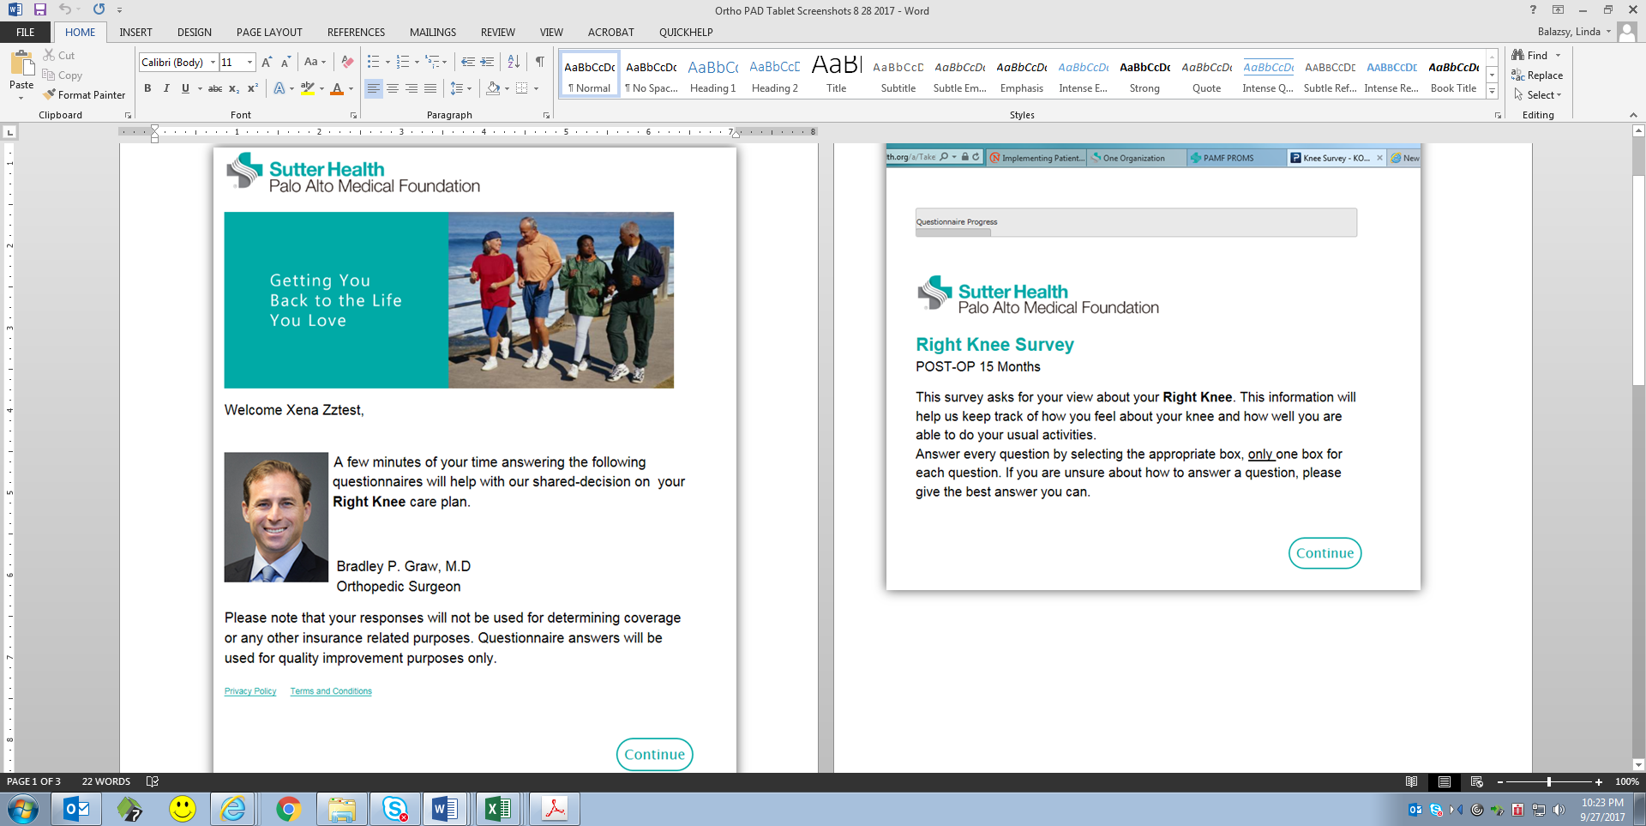

**Questionnaires in Word (to show you the scope of content; we will share the PROMS version for style guideline purposes):**









**PROMS version of the HOOS Questionnaire**

